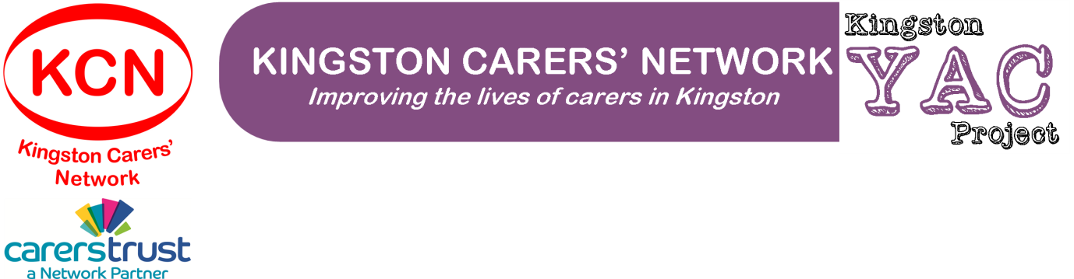
Referral to Kingston Carers’ Network – Young Adult Carers’ Project
Referrer Information
Date of referral: | Name of referrer:
Relationship to person being referred: | Telephone Contact:  Email Contact:
How do you know about the Young Adult Carers’ Project?

The person you are referring (and their parent/guardian if under 16) MUST be aware of this referral

Young Adult Carer Details
Full name: |  | Date of birth:
Address: |  | Home telephone:  Mobile telephone:  Email:
Name of main guardian (if applicable): |  | Relationship to carer:
Address of main guardian, if different from carer’s address: |  | Main guardian’s:  Home telephone:  Mobile telephone:  Email:
Carer’s School, College or University (if applicable): |  | Is the school, college or university aware of the caring situation? (Please tick)  YES  NO  DON’T KNOW
School, College or University contact person (if applicable): |  | Contact telephone:  Contact email:
Ethnicity (please tick):
White |  | Mixed/Multiple Ethnic Groups
English/Welsh/Scottish/Northern Irish/British |  | White and Black Caribbean
Irish |  | White and Black African
Gypsy/Roma |  | White and Asian
Irish Traveller |  | Any other mixed/multiple ethnic background
Any other White background
 |  | Asian/Asian British
Black/African/Caribbean/Black British |  | Indian
African |  | Pakistani
Caribbean |  | Bangladeshi
Any other Black/African/Caribbean background |  | Chinese
 |  | Any other Asian background
Other Ethnic Group
Arab |  | Prefer not to say
Any other ethnic group

Cared For Details
Full name: | Date of birth:
Address (if different from carer’s address): | Relationship to carer:
Diagnosis / Nature of condition: | Nature of care provided by carer:

Additional Information – Young Adult Carer
Please provide details of any other relevant information about the person you’re referring (e.g. allergies, medication, health needs, access needs)

Additional Information – Family Circumstances
Please provide details of any other relevant information about the family context of the person you’re referring (e.g. who else lives at home, other agencies involved currently or in the recent past)

Please send this form to yac@kingstoncarers.org.uk or by post to Emma Bell at Kingston Carers’ Network, The Noble Centre, 109a Blagdon Road, New Malden, Surrey, KT3 4BD

